Hands-on Exercise #1: ScienceDirect BTM710 Fall 2025
Step 1 Go to the Computer Science & IT Subject Guide:
https://library.senecapolytechnic.ca/computer
Step 2 Click the tab: Articles & Reports.
Scroll down and select the database: ScienceDirect.
Step 3 Search for a research article.
Type your keywords in the search box: chatbots communication. Click Search.

Step 4 How many results? __________

Step 5 Go to the left side of the screen.
Refine your results by Article Type. Select research articles.

Step 6 How many research articles? _____________

Step 7 Find the research article (approximately #10). Click on the title.
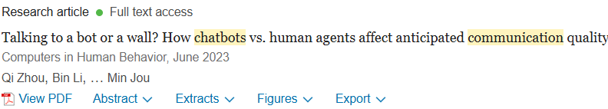

Step 8 Circle the correct answer:
- How many authors? 2 4 6
- Does the article include the research methods and design? Yes or No
- How many participants were recruited for Study 2(Research Design)? 100 275 341
- Does this article provide a list of References? Yes or No
- Cited by how many articles? 49 65 99
- What is name of the publication? _______________________
- Is this a scholarly journal article? Yes or No
Step 9 Look at the database interface. Write four database search features.

- __________________________ 3. __________________________________

- ____________________________ 4. _______________________________

Congratulations! You completed your ScienceDirect database search.

